UNIT 4
Lesson 4 – WHERE DOES THE CAT SLEEP?

1 a) Do you remember?

Sjećaš li se?
Who? Tko?
Where? Gdje?
When? Kada?
Why? Zašto?
What? Što?

b) Try to use your own hand to practise wh- questions.
Pokušaj uvježbati upitne riječi uz pomoć svoje ruke.

c) Complete the questions with the correct words.
Upotrijebi točnu upitnu riječ da dobiješ pitanje.
WHICH?
Koji? Koja? Koje?
WHY?
Zašto?
WHO?
Tko?
WHEN?
Kada?
WHERE?
Gdje?

1 Where does your cat sleep? In her bed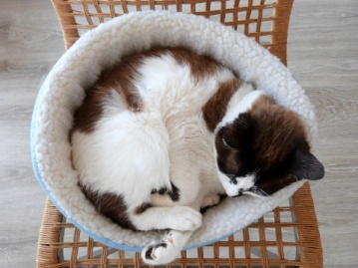.
Gdje spava tvoja mačka? U svom krevetu.



2 __________ do you go swimming? In the summer .
______ ideš plivati? Ljeti.




3 _____________ does your brother
play tennis? Beacuse he likes it
__________ tvoj brat igra tenis? Zato što to voli.

4___________ makes cake? Grandma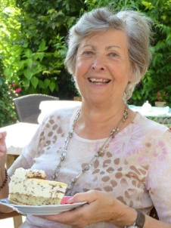.
_______ pravi tortu? Baka.


5 _________ TV show do you watch
in the evening?
_______ seriju gledaš navečer? The Big Bang Theory.
Teoriju velikog praska.


6 _________ do you do after school? I meet my friends.
______ radiš poslije škole? Sastajem se sa svojim prijateljima.
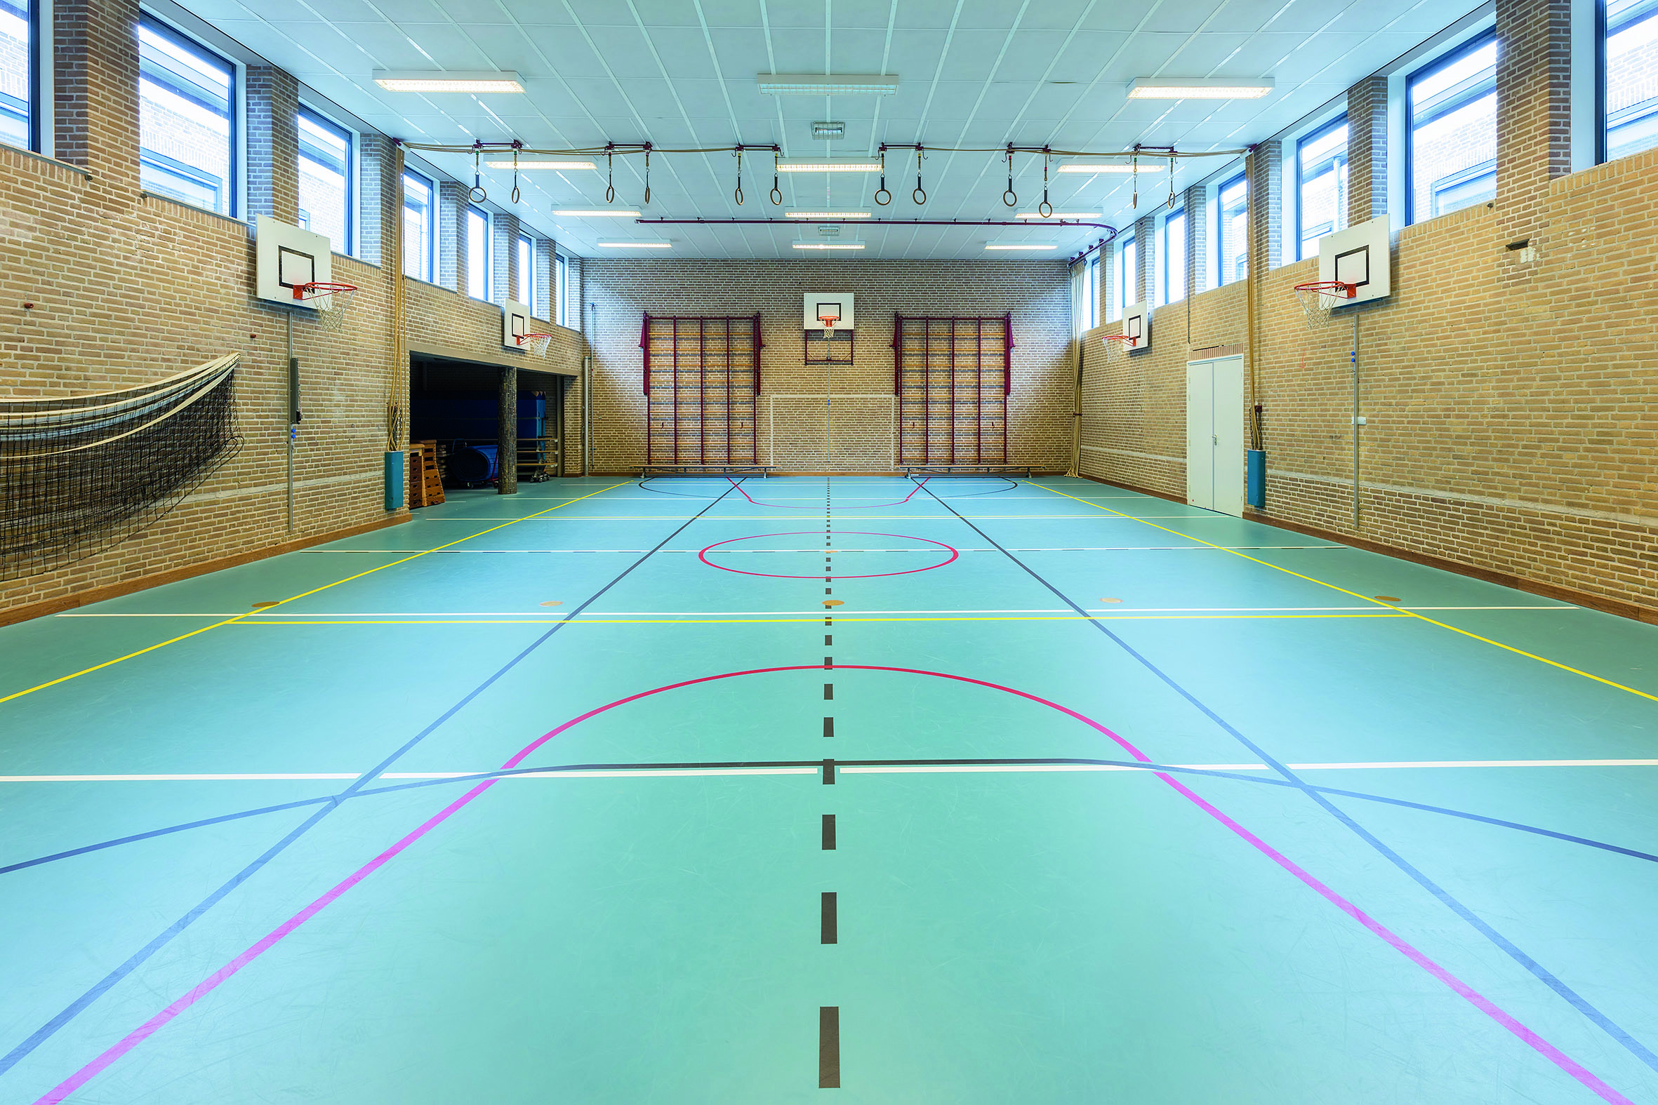


7 ________do you have football practice?
_____ imaš trening nogometa? At the school gym.
U školskoj dvorani.

- 2 a) How often? Koliko često?
Take a look at the table below.
It shows how often things can happen.
Pogledaj tablicu. Pokazuje koliko često se nešto događa.

ALWAYS
UVIJEK
USUALLY
UGLAVNOM / REDOVITO
OFTEN
ČESTO
SOMETIMES
PONEKAD
HARDLY EVER
RIJETKO
NEVER
NIKADA

b) How often do these things happen? Circle the correct answer.
Koliko često se ove stvari događaju? Zaokruži točan odgovor.
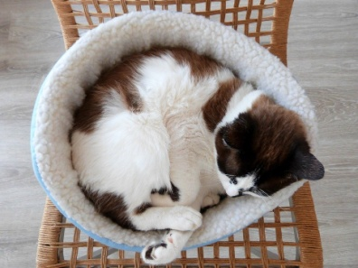

1 How often does your cat sleep in her bed? Always. / Sometimes.
Koliko često tvoj mačka spava u svom krevetu?

2 How often do you go swimming? Sometimes. / Hardly ever.
Koliko često plivaš / ideš na plivanje?

3 How often does your friend play tennis? Never. / Often
Koliko često tvoj prijatelj igra tenis?

4 How often does your grandma make cakes? Always. / Often.
Koliko često tvoj baka pravi kolače / torte?

5 How often do you watch TV ? Often. / Sometimes.
Koliko često gledaš TV ?


6 How often do you meet your friends. Often. / Sometimes.
Koliko četo se sastaješ sa svojim prijateljima?

7 How often do you have football practice? Never. / Often.
Koliko često imaš nogometni trening?

c) How often do you…?
Read the sentences. Pick a word from the box above.
Koliko često…? Pročitaj rečenice.
Izaberi riječ koja najbolje opisuje koliko često radiš ove stvari.

1 How often do you walk to school? 
Koliko često ideš pješice u školu?
I __________________ walk to school.

2 How often do you go out with your friends? 
Koliko često izlaziš s prijateljima vani?

I __________________ go out with my friends.

3 How often do you skip breakfast?
Koliko često preskačeš doručak?
I __________________ skip breakfast.

4 How often do you stay up late? 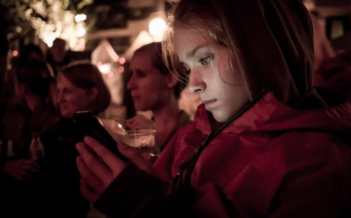
Koliko često ostaješ budan / budna do kasno.

I __________________ stay up late.
5 How often do you eat fruit? 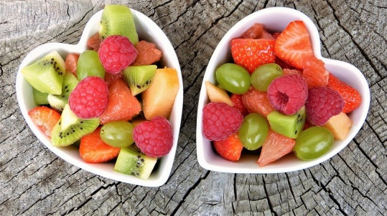
Koliko često jedeš voće?

I __________________ eat fruit.

6 How often do you eat fast food? 
Koliko često jedeš brzu hranu?
I __________________ eat fast food.

7 How often do you play video games? 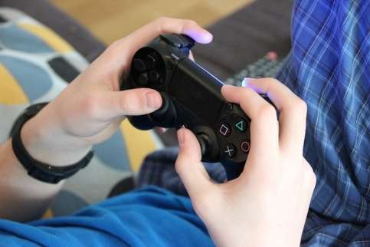
Koliko često igraš video igrice?

I __________________ play video games.

b) Copy the sentences from task 4 a) on the empty lines.
Prepiši rečenice iz zadatka 4 a) na prazne crte.

1 ________________________________________________ .
2 ________________________________________________ .
3 ________________________________________________ .
4 ________________________________________________ .
5 ________________________________________________ .
6 ________________________________________________ .
7 ________________________________________________ .

